Game Design Document (GDD)

Jason Kramer, Brendan LeTourneau, Evan Kosmos & Gage Hansberry (Team KGBJ)

Jousting

o==[]:::::::::::::::::::::::::>

Jamboree

***‘Take a Stab at It’*** - Seoyune

This page: Table of Contents and Team Member Listing

|  |  |  |
| --- | --- | --- |
| Table of Contents  [1 Game Overview](https://n-xovwktmtjsnaxyc2mwes2xu7pohqedmdm6zjw5q-2lu-script.googleusercontent.com/userCodeAppPanel)  [2 High Concept](https://n-xovwktmtjsnaxyc2mwes2xu7pohqedmdm6zjw5q-2lu-script.googleusercontent.com/userCodeAppPanel)  [3 Unique Selling Points](https://n-xovwktmtjsnaxyc2mwes2xu7pohqedmdm6zjw5q-2lu-script.googleusercontent.com/userCodeAppPanel)  [4 Platform Minimum Requirements](https://n-xovwktmtjsnaxyc2mwes2xu7pohqedmdm6zjw5q-2lu-script.googleusercontent.com/userCodeAppPanel)  [5 Competitors / Similar Titles](https://n-xovwktmtjsnaxyc2mwes2xu7pohqedmdm6zjw5q-2lu-script.googleusercontent.com/userCodeAppPanel)  [6 Synopsis](https://n-xovwktmtjsnaxyc2mwes2xu7pohqedmdm6zjw5q-2lu-script.googleusercontent.com/userCodeAppPanel)  [7 Game Objectives](https://n-xovwktmtjsnaxyc2mwes2xu7pohqedmdm6zjw5q-2lu-script.googleusercontent.com/userCodeAppPanel)  [8 Game Rules](https://n-xovwktmtjsnaxyc2mwes2xu7pohqedmdm6zjw5q-2lu-script.googleusercontent.com/userCodeAppPanel)  [9 Game Structure](https://n-xovwktmtjsnaxyc2mwes2xu7pohqedmdm6zjw5q-2lu-script.googleusercontent.com/userCodeAppPanel)  [10 Game Play](https://n-xovwktmtjsnaxyc2mwes2xu7pohqedmdm6zjw5q-2lu-script.googleusercontent.com/userCodeAppPanel)  [10.1 Game Controls](https://n-xovwktmtjsnaxyc2mwes2xu7pohqedmdm6zjw5q-2lu-script.googleusercontent.com/userCodeAppPanel)  [10.2 Game Camera](https://n-xovwktmtjsnaxyc2mwes2xu7pohqedmdm6zjw5q-2lu-script.googleusercontent.com/userCodeAppPanel)  [10.2.1 HUD](https://n-xovwktmtjsnaxyc2mwes2xu7pohqedmdm6zjw5q-2lu-script.googleusercontent.com/userCodeAppPanel)  [10.2.2 Maps](https://n-xovwktmtjsnaxyc2mwes2xu7pohqedmdm6zjw5q-2lu-script.googleusercontent.com/userCodeAppPanel)  [11 Players](https://n-xovwktmtjsnaxyc2mwes2xu7pohqedmdm6zjw5q-2lu-script.googleusercontent.com/userCodeAppPanel)  [11.1 Characters](https://n-xovwktmtjsnaxyc2mwes2xu7pohqedmdm6zjw5q-2lu-script.googleusercontent.com/userCodeAppPanel)  [11.2 Metrics](https://n-xovwktmtjsnaxyc2mwes2xu7pohqedmdm6zjw5q-2lu-script.googleusercontent.com/userCodeAppPanel)  [11.3 States](https://n-xovwktmtjsnaxyc2mwes2xu7pohqedmdm6zjw5q-2lu-script.googleusercontent.com/userCodeAppPanel)  [11.4 Weapons](https://n-xovwktmtjsnaxyc2mwes2xu7pohqedmdm6zjw5q-2lu-script.googleusercontent.com/userCodeAppPanel)  [12 Player Line-up](https://n-xovwktmtjsnaxyc2mwes2xu7pohqedmdm6zjw5q-2lu-script.googleusercontent.com/userCodeAppPanel)  [13 NPC](https://n-xovwktmtjsnaxyc2mwes2xu7pohqedmdm6zjw5q-2lu-script.googleusercontent.com/userCodeAppPanel)  [13.1 Enemies](https://n-xovwktmtjsnaxyc2mwes2xu7pohqedmdm6zjw5q-2lu-script.googleusercontent.com/userCodeAppPanel)  [13.1.1 Enemy States](https://n-xovwktmtjsnaxyc2mwes2xu7pohqedmdm6zjw5q-2lu-script.googleusercontent.com/userCodeAppPanel)  [13.1.2 Enemy Spawn Points](https://n-xovwktmtjsnaxyc2mwes2xu7pohqedmdm6zjw5q-2lu-script.googleusercontent.com/userCodeAppPanel)  [13.2 Allies / Companions](https://n-xovwktmtjsnaxyc2mwes2xu7pohqedmdm6zjw5q-2lu-script.googleusercontent.com/userCodeAppPanel)  [13.2.1 Ally States](https://n-xovwktmtjsnaxyc2mwes2xu7pohqedmdm6zjw5q-2lu-script.googleusercontent.com/userCodeAppPanel)  [13.2.2 Ally Spawn Points](https://n-xovwktmtjsnaxyc2mwes2xu7pohqedmdm6zjw5q-2lu-script.googleusercontent.com/userCodeAppPanel)  [14 Art](https://n-xovwktmtjsnaxyc2mwes2xu7pohqedmdm6zjw5q-2lu-script.googleusercontent.com/userCodeAppPanel)  [14.1 Setting](https://n-xovwktmtjsnaxyc2mwes2xu7pohqedmdm6zjw5q-2lu-script.googleusercontent.com/userCodeAppPanel)  [14.2 Level Design](https://n-xovwktmtjsnaxyc2mwes2xu7pohqedmdm6zjw5q-2lu-script.googleusercontent.com/userCodeAppPanel)  [14.3 Audio](https://n-xovwktmtjsnaxyc2mwes2xu7pohqedmdm6zjw5q-2lu-script.googleusercontent.com/userCodeAppPanel)  [15 Wish List](https://n-xovwktmtjsnaxyc2mwes2xu7pohqedmdm6zjw5q-2lu-script.googleusercontent.com/userCodeAppPanel)   |  | | --- | |  | | Game Development Team Members    PRODUCER  Brendan Le Tourneau    PRODUCTION MANAGER  Brendan Le Tourneau    PRODUCTION COORDINATOR  Jason Kramer  GAME DESIGNERS  Gage Hansberry, Evan Kosmos, Jason Kramer, Brendan Le Tourneau  SYSTEMS/IT COORDINATOR  Evan Kosmos  PROGRAMMERS  Jason Kramer, Brendan Le Tourneau  TECHNICAL ARTISTS  Gage Hansberry  AUDIO ENGINEERS  Gage Hansberry  UX TESTERS  Gage Hansberry, Evan Kosmos, Jason Kramer, Brendan Le Tourneau |

|  |
| --- |
|  |

# 1 Game Overview

Title: Jousting Jamboree

Platform: PC/Mac Standalone

Genre: Casual/Action

Rating: (E10+) ESRB

Target: Casual gamer (aging from 12 - 30)

Release date: December, 2019

Publisher: KGBJ Inc.

Description: Jousting Jamboree is a physics based jousting game where the player is given random weapons/mounts/effects each round , and an AI adversary is given the same equipment. The player is tasked with knocking the AI adversary off of their mount. The first one to touch the ground loses.

# 2 High Concept

Jousting Jamboree is a physics based jousting game where the player is given random weapons/mounts/effects each round , and an AI adversary is given the same equipment. The player is tasked with knocking the AI adversary off of their mount. The first one to touch the ground loses.

# 3 Unique Selling Points

Random round effects

Beautiful graphics

Ragdoll physics

Easy to pick up and play

# 4 Platform Minimum Requirements

Basic CPU (i.e. Intel i3)

Graphics: minimal graphics required, integrated graphics card would be suitable

PC or Mac OS

# 5 Competitors / Similar Titles

Soccer Physics

Totally Accurate Battle Simulator

Toribash

# 6 Synopsis

When Santa finds out that he was a product of Coca Cola, he is lost about what his purpose in life is and wants revenge on Coke. In a search to find purpose and recruit an army of amazing jousters, he takes his favorite three elves and goes back in time to Medieval Times where he creates and runs his own Jousting Tournament at the Jousting Jamboree. He sends his elves out into the town to find the best warriors, and the winner gets the opportunity to be sent into the present time and help take down the evil Coca Cola who created Santa to sell more Coke. Due to copyright issues we removed all references to Santa and Coca Cola

# 7 Game Objectives

Knock adversary off of mount using your weapon. Win rounds and complete objectives to unlock fun accessories for your rider.

# 8 Game Rules

Player and adversary charge towards each other each round. The first rider to hit the ground loses that round. The first to win 5 rounds, wins the match, and the match ends. The player can move their mount, with restrictions. They can also move their weapon with restrictions, and adjust the rotation of their weapon. The weapon will slowly drop depending on its weight, and the player will need to constantly adjust its position such that it hits the adversary.

# 9 Game Structure

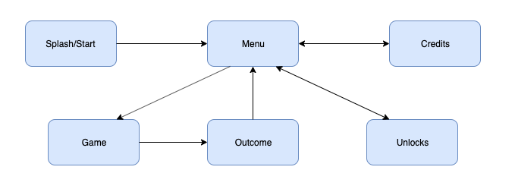

# 10 Game Play

## 10.1 Game Controls

|  |  |  |
| --- | --- | --- |
| **Action** | **Buttons** | **Description** |
| Menu Navigation | Mouse movement/click | navigates menus |
| Move Mount | WASD | Moves mount forward/left/backward/right with some restrictions so the player can’t just roam free |
| Adjust weapon position | Mouse Movement | Moves rider arm/weapon up/left/down/right |
| Adjust weapon rotation | Left click + Mouse Movement | Rotates player’s weapon |
| Main Menu | “P” key | Go back to Main Menu from any scene |
| Unlock All Items | Press “3” and “4” simultaneously | Cheat code to unlock all items in the game automatically. Used for testing purposes |
| Reset items to default | Press “3” and “4” simultaneously | Cheat code to reset items back to default. Used for testing purposes |

## 10.2 Game Camera

* Menu
  + Starts looking at the main menu, when menu item is clicked, camera moves to the location of new menu
* Gameplay
  + Camera follows behind player and mount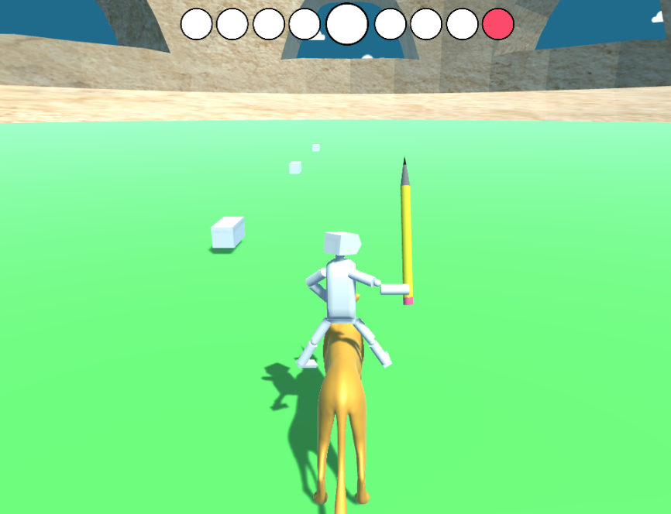
  + When enemy rider is demounted, a second camera follows them in a “split screen” mode

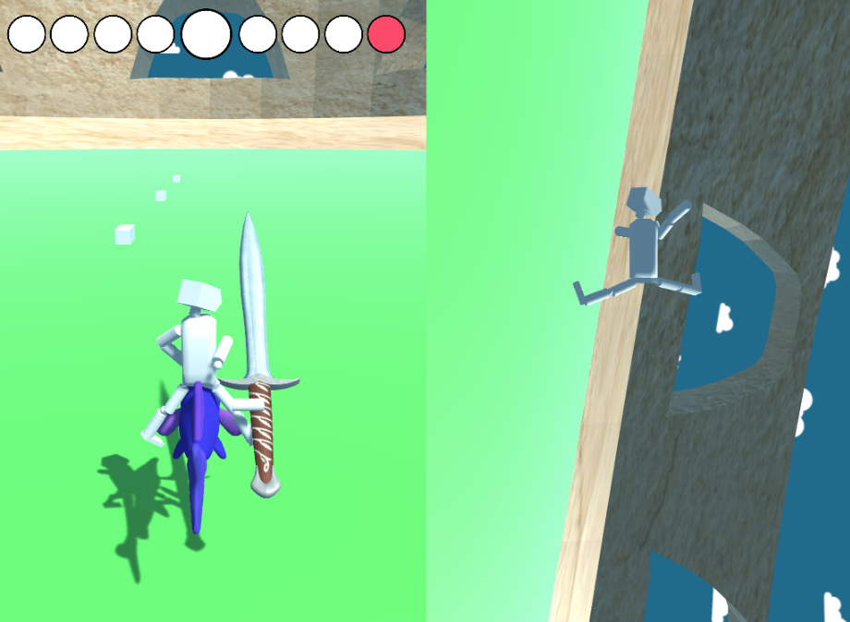

### 10.2.1 HUD

There will be 9 circles at the top of the screen, each representing a round. The 5th circle will be bigger. If the Player wins a round, a blue circle is filled in starting from the left side. If the AI wins a round, a red circle is filled in starting on the right side. It is a best 5/9, so the first to get to the 5th circle in the middle wins.



Ex: This current score means that Player has won 1 round and AI has won 2.

### 10.2.2 Maps

Single Map of colosseum where Jousting Jamboree is held.

# 11 Players

## 11.1 Characters

Just the single player and the NPC opponent.

## 11.2 Metrics

Mounts

|  |  |  |
| --- | --- | --- |
| Name: | Speed: | Hop Power |
| Horse | 25 | 10 |
| Cheetah | 35 | 4 |
| Beach Ball | 15 | 15 |
| Elephant Fish | 20 | 10 |

## 11.3 States

**Move:** Player is immediately moving via riding their mount. They are anchored to their mount unless hit by their opponent.

**Death:** The player is knocked off their mount and enters a ragdoll physics effect, followed by a second camera.

## 11.4 Weapons

Each Weapon has 5 metrics, it’s x and y movement speed, it’s x and z rotational speed, and it’s weight/falling speed, the movement restrictions are also a stat but those are arena dependant

|  |  |  |  |  |  |
| --- | --- | --- | --- | --- | --- |
| Name: | X Speed | Y Speed | X Rotation | Z Rotation | Weight |
| Sword | .2 | .2 | 2 | 2 | 3 |
| Bat | .1 | .1 | 1 | 1 | 1 |
| Axe | .2 | .2 | 1 | 1 | 8 |
| Candy Cane | .5 | .5 | 2 | 2 | .3 |
| Chainsaw | .3 | .3 | 5 | 3 | 5 |
| Frying Pan | .5 | .5 | 2 | 3 | 1 |
| Lamp | .3 | .3 | 2 | 2 | 3 |
| Light Saber | 1 | 1 | 9 | 9 | 1 |
| Microphone | .4 | .4 | 7 | 7 | 1 |
| Pencil | 1 | 1 | 7 | 7 | 0 |
| Tennis Racket | .4 | .4 | 4 | 4 | 1 |
| Thor Hammer | .2 | .2 | 1 | 1 | 5 |

# 12 Player Line-up

Original Models:

Rider

Pencil

Coliseum

Microphone

# 13 NPC

## 13.1 Enemies

Only one enemy (NPC), which is basically a copy of you in terms of the mount they are riding and weapon they are using.

13.1.1 Enemy States

**Move:** NPC is immediately moving via riding their mount. They are anchored to their mount unless hit by their opponent.

**Death:** The NPC is knocked off their mount and enters a ragdoll physics effect, followed by a second camera.

### 13.1.2 Enemy Spawn Points

At the opposite end of the arena from the player so they are lined up to charge their mounts at each other.

# 14 Art

## 14.1 Setting

The jousting is held in a coliseum arena that we designed ourselves.

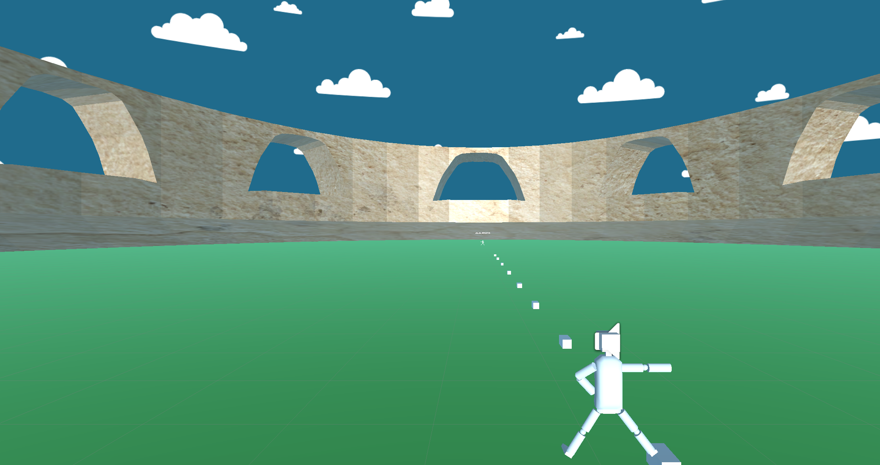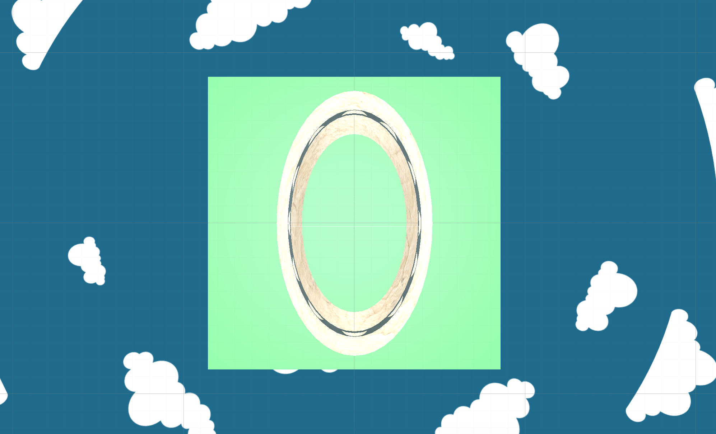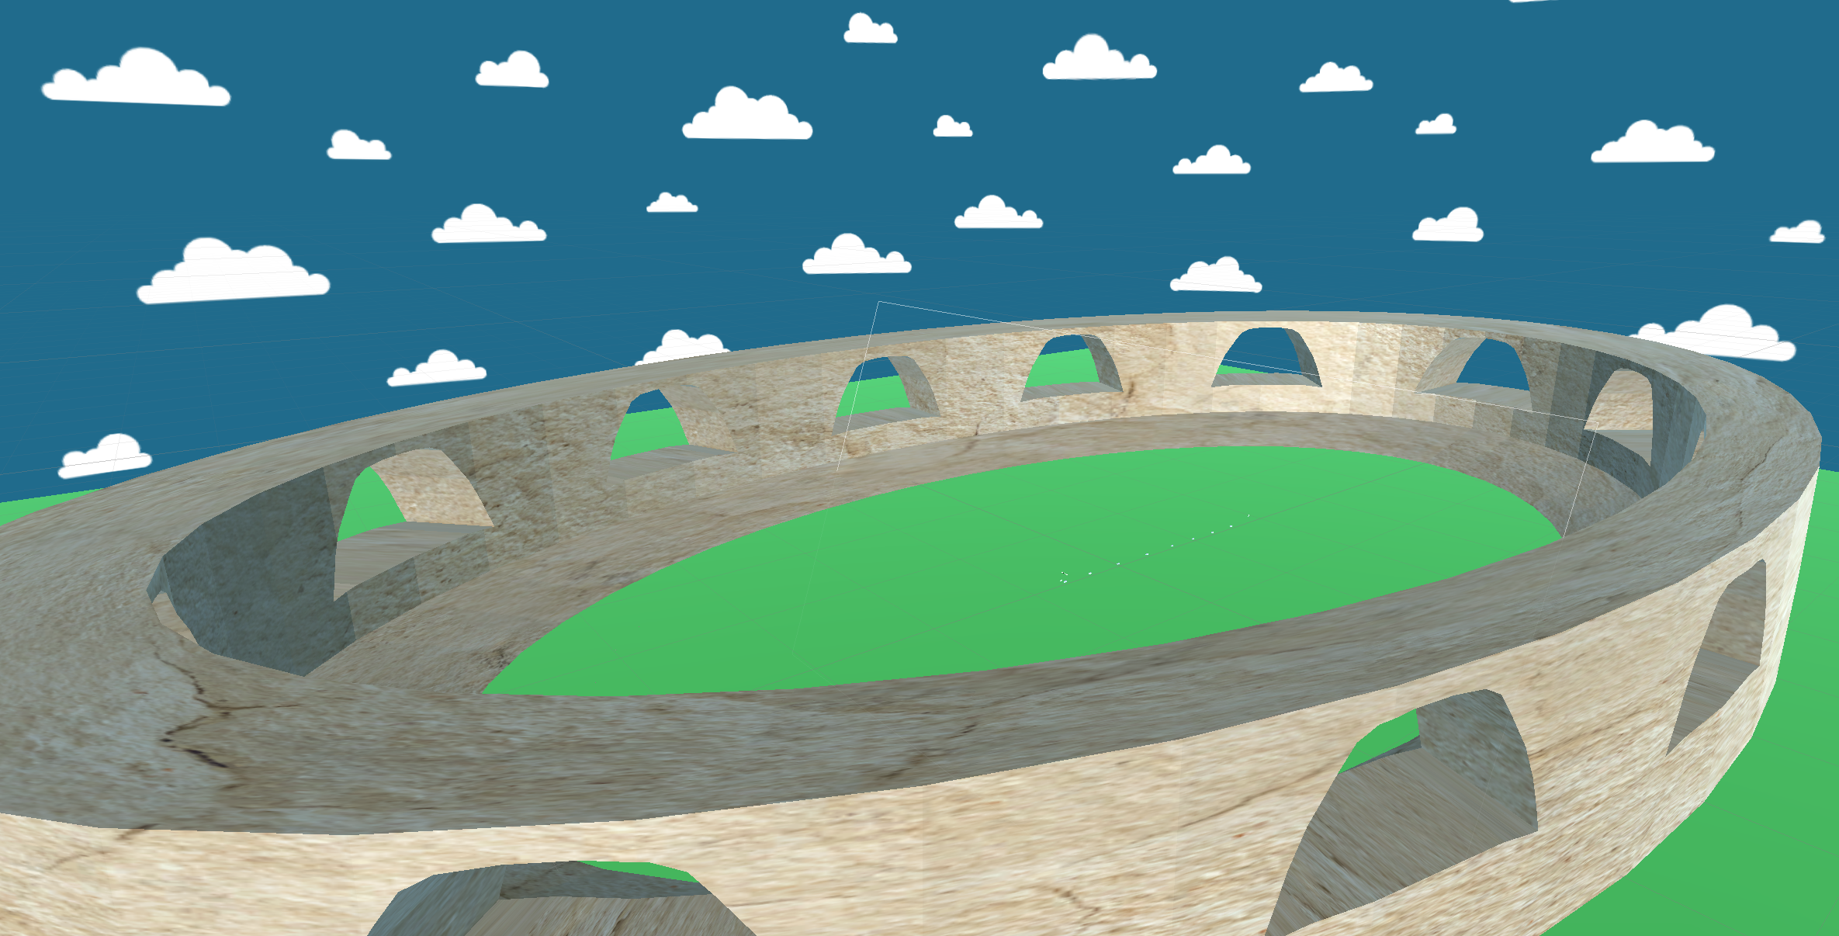

## 14.2 Level Design

The coliseum is a large ovaloid arena where the player and enemy partake in the jousting.

## 14.3 Audio

|  |  |  |
| --- | --- | --- |
| Name | Category | Description |
| IntroMusic-HeroicAge-KevinMacleoud | Background Music | Plays During Game |
| CalmJoustingSong-PippinTheHunchBack-KevinMacLeod | Music | Plays in the Unlocks Scene |
| HorseShort | FX | The mounts galloping sound |
| BodySoundFall-Zapsplat | FX | Plays when player/enemy hits the ground |
| HitSound-FoleyWalkers-Zapsplat | FX | Plays when player/enemy gets hit with weapon |

# 15 Wish List

More Variants like gravity and camera

Hats

More rider types

Multiplayer Mode

Multiple Arenas